Bangladesh Medical Association (BMA)
List of Life Member-18
48. BMA Nilphamari Branch

Sl No | Voter No | Voter Details
1 | Voter No  LM-4800001  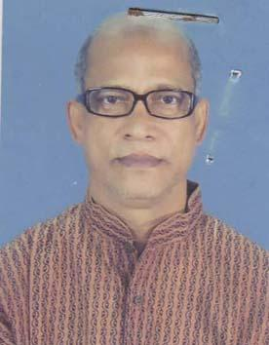 | DR. MD. MAUTAZUL ISLAM MINTOO  F/Name: Late Dr. A. Mazid Chowdhury  M/Name: Late Noor Nahar Begum Laly  BM & DC Reg. No: 6700  NID: 7326401321752  Cell: 01712204527  Address: Sabujpara, Nilphamari-5300.  Blood Group: A+
2 | Voter No  LM-4800002  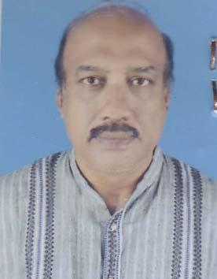 | DR. MD. MAZIBUL HASAN CHOWDHURY  F/Name: Matiar Rahman Chowdhury  M/Name: Begum Khadiza Chowdhury  BM & DC Reg. No: 8844  NID:  Cell: 01712932704  Address: :Shaboz Para, Capt Bashar Road, Nilphamray.  Blood Group:
3 | Voter No  LM-4800003 | DR. MD. HASAN HABIBUR RAHMAN  F/Name: Md. Harunar Rashid  M/Name: Mrs. Hasna Banu  BM & DC Reg. No: 25383  NID: 7326409394926  Cell: 01718772646  Address: Habib Manjil, Natun Bazar Nilphamari, Nilphamari-5300.  Blood Group: A+
4 | Voter No  LM-4800004  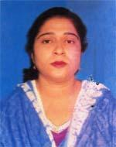 | DR. ROZINA AKHTER  F/Name: Late Md. Jaidul Hoque Sarker  M/Name: Mrs. Fatema Begum  BM & DC Reg. No: 30987  NID: 7326409394927  Cell: 01721566843  Address: Habib Manzil Notun Bazar, Nilphamari  Blood Group: O+
5 | Voter No  LM-4800005  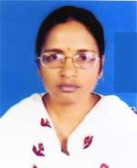 | DR. JOYSHREE RANI SARKER  F/Name: Promod Chandra Sarker  M/Name: Priti Rani Sarker  BM & DC Reg. No: 34202  NID: 2726409182924  Cell: 01714679359  Address: Nilphamari Diabetic Hospital Campus, Nilphamari  Blood Group: O+
6 | Voter No  LM-4800006 | DR. MD. HAMDULLAH  F/Name: Md. Nurullahil Quddusi  M/Name: Mrs. Shahida  BM & DC Reg. No: 54797  NID: 8524905058872  Cell: 01944007080  Address: UHC, DIMLA,, Nilphamari.  Blood Group: A+
7 | Voter No  LM-4800007 | DR. DILIP KUMAR ROY  F/Name: Haripada Roy  M/Name: Usha Rani Roy  BM & DC Reg. No: 25018  NID: 7326407395487  Cell: 01712223095  Address: Shahipara, Nilphamari Sadar, Post+Dist-Nilphamari, Post Code-5300  Blood Group: O+
8 | Voter No  LM-4800008 | DR. MD. SHOHORAB HOSSAIN  F/Name: Md. Nurul Islam  M/Name: Mrs. Rokeya Begum  BM & DC Reg. No: 31289  NID: 8524910128525  Cell: 01716912084  Address: 248/1, Central Road, Rangpur  Blood Group: AB+
9 | Voter No  LM-4800009 | DR. MD. MANIRUZZAMAN  F/Name: Md. Shamsul Haq  M/Name: Most. Monowara Begum  BM & DC Reg. No: 50768  NID: 7316411280698  Cell: 01717623239  Address: Nilprotiva Para, Dakbanglo Road, Nilphamari  Blood Group: O+
10 | Voter No  LM-4800010 | DR. MD. JAHANGIR ALAM  F/Name: Late Md. Ramjan Ali  M/Name: Jahanara Begum  BM & DC Reg. No: 19808  NID: 7326407216184  Cell: 01712812100  Address: Doctor\'s Quarters , MCWC, Nilphamari  Blood Group: B+
11 | Voter No  LM-4800011  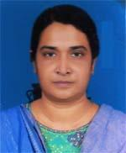 | DR. ROKSANA BEGUM  F/Name: Late Rahen Uddin Molla  M/Name: Late Sayera Khatun  BM & DC Reg. No: 19805  NID: 7326407216185  Cell: 01716353361  Address: Doctor\'s Quarters , MCWC, Nilphamari  Blood Group: B+
12 | Voter No  LM-4800012 | DR. PRODIP KUMAR ROY  F/Name: Subhash Chandra Roy  M/Name: Late Sona Rani Roy  BM & DC Reg. No: 56615  NID: 19866125217236016  Cell: 01717563825  Address: Upazilla Health Complex, Dimla, Nilphamari  Blood Group: A+
13 | Voter No  LM-4800013  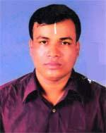 | DR. MD. AYNUL HAQUE  F/Name: Md. Nasir Uddin (late)  M/Name: Jorina Khatun (late)  BM & DC Reg. No: 46669  NID: 75280304406240  Cell: 01758123445  Address: Choto Routa, Bonowarir Mor, Domar, Nilphamari  Blood Group: B+
14 | Voter No  LM-4800014 | DR. SHAH MD. MOAZZEM HOSSAIN  F/Name: Late Mozammel Hossain  M/Name: Raoshan Ara Akhter  BM & DC Reg. No: 36122  NID: 7326405195502  Cell: 01716355480  Address: Vill-Aragi Kanial Khata, Post+Dist-Nilphamari  Blood Group: A+
15 | Voter No  LM-4800015 | DR. MD. MAHBUB HASAN  F/Name: Late Motaher Hossain  M/Name: Mahmuda Khatun  BM & DC Reg. No: 4568  NID: 8524903031993  Cell: 01712178270  Address: Upazilla Health Complex, Jaldhaka, Nilphamari  Blood Group: B+
16 | Voter No  LM-4800016 | DR. HERAMBO KUMAR ROY  F/Name: Kamakhya Charon Roy  M/Name: Soti Rani Roy  BM & DC Reg. No: 21034  NID: 8524904189564  Cell: 01718562172  Address: Nilphamari.  Blood Group: A+
17 | Voter No  LM-4800017  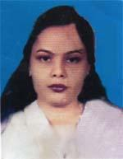 | DR. MST. WABAIDA NASRIN  F/Name: Md. Abdul Wahab Sarker  M/Name: Most. Jahanara Begum  BM & DC Reg. No: 32013  NID: 7311517750486  Cell: 01712531983  Address: Upazilla Health Complex, Domcn, Nilphamari  Blood Group: AB+
18 | Voter No  LM-4800018 | DR. MD. MEHSAN CHOWDHURY  F/Name: Md. Mamtazul Islam Chowdhury  M/Name: Shahana Islam  BM & DC Reg. No: 60231  NID: 19877326401322904  Cell: 01716828832  Address: Vill-Shabujpara, post-Nilphamari, Thana-Nilphamari, Dist-Nilphamari  Blood Group: A-

